Gravity Worksheet
Part 1 set up:
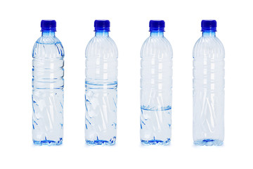
A
B
Full
Half Full
Hypothesis:
Which bottle do you think will fall faster?

Data:

Trial | Which bottle fell faster? A, B or Tie?
1
2
3

Part 2 set up:
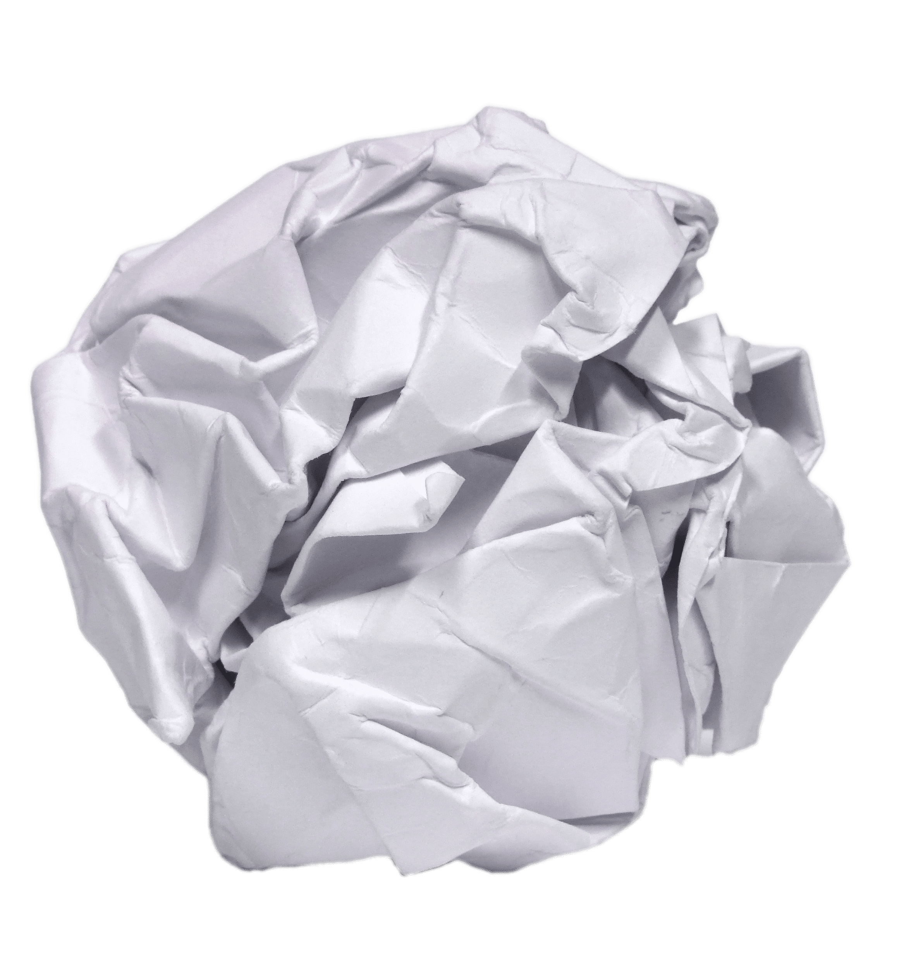
Crumpled
Sheet
Hypothesis:
Which piece of paper will fall faster?

Data:
Trial | Which piece of paper fell faster?
1
2
3

Conclusions:
Was your hypothesis to part 1 correct? Why or why not?

Was your hypothesis to part 2 correct? Why or why not?

Based on part 1, does the weight of an object affect how fast it falls?

Based on part 2, does the shape of an object affect how fast it falls?

